# 



**SHAREBILLS**

A database project on simplified expense sharing among users

Subhash Daggubati

Tejaswi Lakkakula

BalaPavan Kommareddy

Sandeep Anuguthala

Anup Kumar Chittimalla

## **TABLE OF CONTENTS**

1. DATABASE PLANNING ……………………………………………………………………………………………………………..3
2. MISSION STATEMENT
3. MISSION OBJECTIVES
4. STANDARDS DEVELOPMENT
5. DATABASE DESIGN ………………………………………………………………………………………………………………….4
6. BUSINESS RULES
7. ERD DIAGRAM
8. DBMS FEATURES …………………………………………………………………………………………………………………….6
9. DATA DEFINITION LANGUAGE
10. DATA MANIPULATION LANGUAGE

DATABASE PLANNING

1. **MISSION STATEMENT**

Sharebill's mission is to make shared living and travel easier by providing neutral advice, fair judgement, and simplified expense sharing through Database management system.

1. **MISSION OBJECTIVES**

To maintain (INSERT, UPDATE, DELETE) DATA ON USERS

To maintain (INSERT, UPDATE, DELETE) DATA ON TRANSACTIONS

To maintain (INSERT, UPDATE, DELETE) DATA ON GROUPS

To maintain (INSERT, UPDATE, DELETE) DATA ON TRANSACTION_DETAIL

To maintain (INSERT, UPDATE, DELETE) DATA ON GROUP_MEMBERS

To maintain (INSERT, UPDATE, DELETE) DATA ON SETTLEUP_REQUEST

To perform searches on USERS

To perform searches on TRANSACTIONS

To perform searches on GROUPS

To perform searches on TRANSACTION_DETAIL

To perform searches on GROUP_MEMBERS

To perform searches on SETTLEUP_REQUEST

To track the status of settled transactions

To track status of transactions of Group members

To report the monthly transaction of a particular group.

1. **STANDARDS DEVELOPMENT**
2. The user should be a sharebills account holder
3. Transactions such as Group or non-group transaction is allowed
4. Any transaction can involve one or many users including himself
5. User (borrower) can send a Settle up request to another user (lender)
6. User can include the limited users from the group members
7. User can take note of any number of users in the non-group transaction
8. Settle up request should be initiated by borrower and settle up should be done by lender only.

DATABASE DESIGN

1. **BUSINESS RULES**

ShareBills is a database where transactions of all shared expenses between users is stored.

* ShareBills can get transactions from individual users and users from different groups.
* Each user can be a part of none of the group or several groups.
* Each group can have two or more users.
* Every transaction involves two or more users. For example, Walmart expense is a transaction of common groceries with the amount of 200 USD that involved multiple users made on a particular day.
* Each user can have zero or many transactions.
* For each user there is zero settle up request or many settle up requests.
* Every user is identified by User ID. The first name, last name, middle name, email id, and phone number of all users are recorded in the system.
* A borrower can send a settle up request to lender once he repays the amount lent from borrower. Once the lender approves the settle up request, the rows in the Transaction detail entity will be updated.
* Transaction detail entity has information about transaction id, borrower id, debt amount, settled up flag, and settle up request id.
* For every group, group id, group name and group created date is maintained.
* For every single settle up request is known by Request id. In addition, request made by a user, request sent to a user with the request status, request received date, request accepted date, and request group id is stored in the system.
* A particular transaction is recognized by transaction id. Transaction owner id, Lender id along with the transaction group id, transaction date, transaction amount, and a transaction comment are also kept in the database.

1. **ERD DIAGRAM**

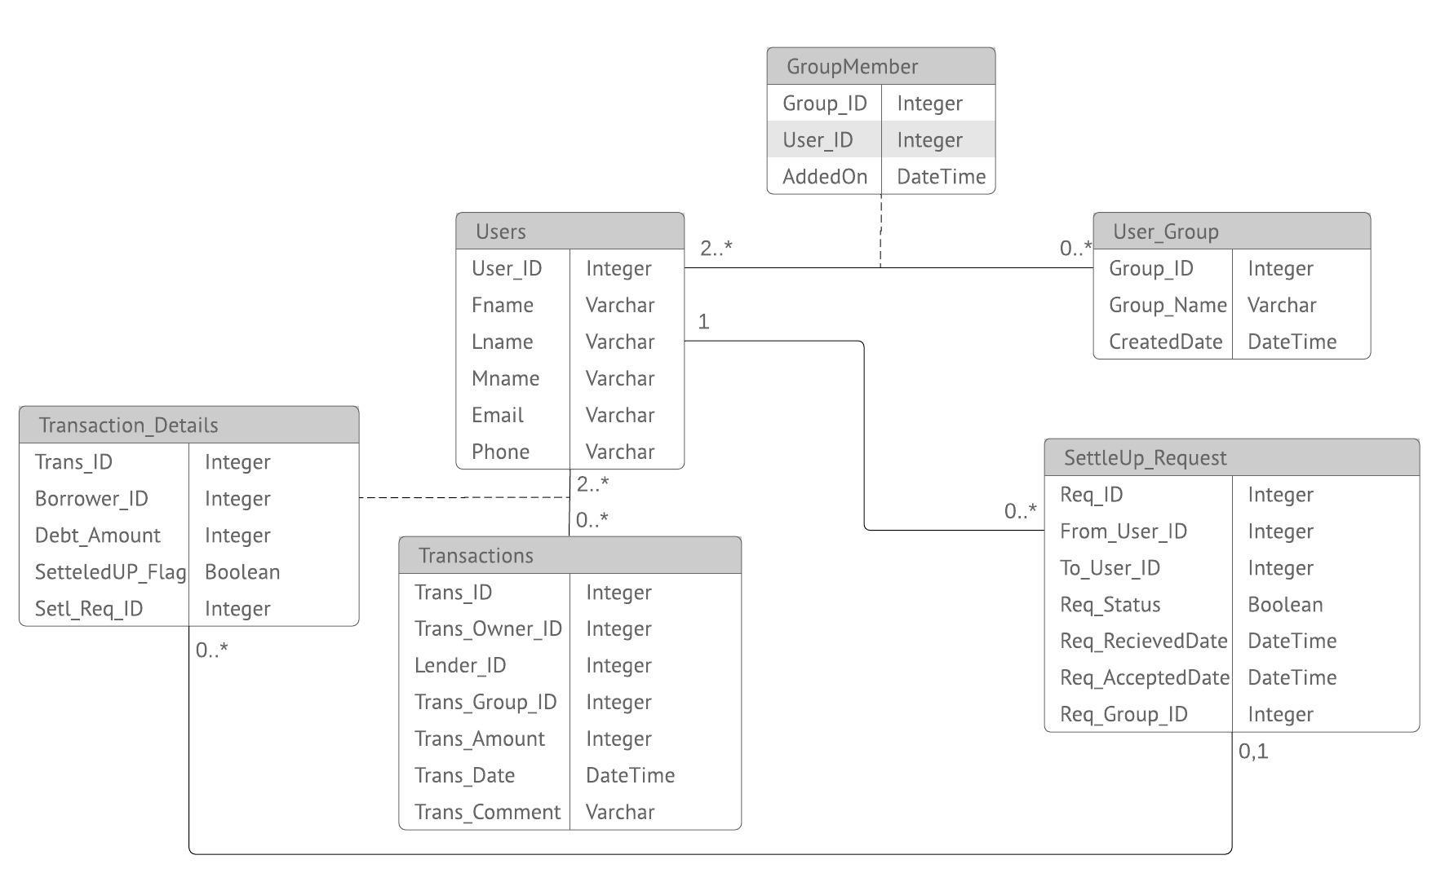

DBMS FEATURES

1. **DATA DEFINITION LANGUAGE**

* **Creating Tables**

CREATE TABLE **Users** (

   User_ID INT not null auto_increment,

   Fname VARCHAR(256),

   Lname VARCHAR(256),

   Mname VARCHAR(256),

   EmailID VARCHAR(256),

   phone VARCHAR(256),

   PRIMARY KEY (User_ID)

);

CREATE TABLE **User_Group** (

   Group_ID INT not null auto_increment,

   Group_Name VARCHAR(256),

CreatedDate DateTime,

   PRIMARY KEY (Group_ID)

);

CREATE TABLE **GroupMember** (

   Group_ID INT,

   User_ID INT,

   AddedOn DATETIME,

   FOREIGN KEY (Group_ID)

       REFERENCES User_Group (Group_ID),

   FOREIGN KEY (User_ID)

       REFERENCES Users (User_ID),

   PRIMARY KEY (Group_ID , User_ID)

);

CREATE TABLE **Transactions** (

   Trans_ID INT not null auto_increment,

   trans_Owner_ID INT,

   Lender_ID INT,

   Trans_Group_ID INT,

   Trans_Amount INT,

   Trans_Date DATETIME,

   Trans_Comment VARCHAR(256),

   FOREIGN KEY (trans_Owner_ID)

       REFERENCES Users (User_ID),

   FOREIGN KEY (Lender_ID)

       REFERENCES Users (User_ID),

   FOREIGN KEY (trans_Group_ID)

       REFERENCES User_Group (Group_ID),

   PRIMARY KEY (Trans_ID)

);

CREATE TABLE **SettleUP_Request** (

   Req_ID INT not null auto_increment,

   From_User_ID INT,

   To_User_ID INT,

   Req_Status BOOLEAN,

   Req_RecievedDate DATETIME,

   Req_AcceptedDate DATETIME,

   Req_Group_ID INT,

   FOREIGN KEY (From_User_ID)

       REFERENCES Users (User_ID),

   FOREIGN KEY (To_User_ID)

       REFERENCES Users (User_ID),

   FOREIGN KEY (Req_Group_ID)

       REFERENCES User_Group (Group_ID),

   PRIMARY KEY (Req_ID)

);

CREATE TABLE **Transaction_Details** (

   Trans_ID INT,

   Borrower_ID INT,

   Debt_Amount INT,

   SettledUp_Flag BOOLEAN,

   setl_Req_ID INT,

   FOREIGN KEY (Trans_ID)

       REFERENCES Transactions (Trans_ID),

   FOREIGN KEY (Borrower_ID)

       REFERENCES Users (User_ID),

foreign key (setl_Req_ID)

references settleup_request (Req_ID),

   PRIMARY KEY (Trans_ID , Borrower_ID)

);

* **Inserting values into the table**

INSERT INTO USERS

( FNAME,LNAME,MNAME,EMAILID,PHONE)

VALUES('JAY','HARKER','NULL','jay@gmail.com','(405)780-2323'),

('CARL','LAYTON','NULL','carl@gmail.com','(405)780-2343'),

('MARC','LEVIN','NULL','marc@gmail.com','(405)780-2353'),

('AMY','DOMINGO','NULL','amy@gmail.com','(405)780-2363'),

('BOBBY','BEST','NULL','bobby@gmail.com','(405)780-2312');

INSERT INTO USER_GROUP

(GROUP_NAME,CREATEDDATE)

VALUES('APARTMENT EXPENSES','2018/12/1'),

('TRIP EXPENSES','2018/12/1');

INSERT INTO GROUPMEMBER

(GROUP_ID,USER_ID,ADDEDON)

VALUES(1,1,'2018/12/1'),

(1,2,'2018/12/1'),

(1,3,'2018/12/1'),

(1,4,'2018/12/1'),

(1,5,'2018/12/1'),

(2,2,'2018/12/1'),

(2,3,'2018/12/1'),

(2,4,'2018/12/1');

INSERT INTO TRANSACTIONS

(TRANS_OWNER_ID,LENDER_ID,TRANS_GROUP_ID, TRANS_AMOUNT,TRANS_DATE,TRANS_COMMENT)

VALUES(1,2,1,100,'2018/12/1','RENT FOR DECEMBER'),

(4,4,2,150,'2018/11/20','TRIP TO DALLAS'),

(2,2,NULL,60,'2018/12/1','RESTAURANT BILL'),

(3,5,NULL,75,'2018/11/20','MOVIE EXPENSES'),

(3,5,1,200,'2018/12/2','Wifi Bill'),

(2,2,2,300,'2018/12/3','Trip to OKC') ;

INSERT INTO TRANSACTION_DETAILS

(TRANS_ID,BORROWER_ID,DEBT_AMOUNT,SETTLEDUP_FLAG,SETL_REQ_ID)

VALUES (1,1,20,0,NULL),

(1,3,20,0,NULL),

(1,4,20,0,NULL),

(1,5,20,0,NULL),

(2,2,50,0,NULL),

(2,3,50,0,NULL),

(3,4,20,0,NULL),

(3,5,20,0,NULL),

(5,1,40,0,NULL),

(5,2,40,0,NULL),

(5,3,40,0,NULL),

(5,4,40,0,NULL),

(6,3,100,0,NULL),

(6,4,100,0,NULL);

INSERT INTO SETTLEUP_REQUEST

(FROM_USER_ID,TO_USER_ID,REQ_STATUS,REQ_RECIEVEDDATE,REQ_ACCEPTEDDATE,REQ_GROUP_ID)

VALUES(1,2,0,'2018/12/1',NULL,1),

(3,4,0,'2018/12/1',NULL,2),

(3,5,0,'2018/12/1',NULL,NULL),

(5,2,0,'2018/12/1',NULL,NULL);

* **Stored Procedure**

CREATE PROCEDURE `Insert_Transaction_Details` (IN INPUT TEXT,

IN delimiter VARCHAR(10), IN debt_amount Int, in trans_id int)

BEGIN

DECLARE cur_position INT DEFAULT 1 ;

DECLARE remainder TEXT;

DECLARE cur_string VARCHAR(1000);

DECLARE delimiter_length TINYINT UNSIGNED;

SET remainder = input;

SET delimiter_length = CHAR_LENGTH(delimiter);

WHILE CHAR_LENGTH(remainder) > 0 AND cur_position > 0 DO

SET cur_position = INSTR(remainder, delimiter);

IF cur_position = 0 THEN

SET cur_string = remainder;

ELSE

SET cur_string = LEFT(remainder, cur_position - 1);

END IF;

IF TRIM(cur_string) != '' THEN

INSERT INTO transaction_details (Trans_ID, Borrower_ID, Debt_Amount,SettledUp_Flag) VALUES (trans_ID,cast(cur_string as unsigned), debt_amount,0);

commit;

END IF;

SET remainder = SUBSTRING(remainder, cur_position + delimiter_length);

END WHILE;

END

* **Triggers**

/*AFTER INSERT SETTLEUP_REQUEST*/

CREATE DEFINER=`root`@`localhost` TRIGGER `settleup_request_AFTER_INSERT` AFTER INSERT ON `settleup_request` FOR EACH ROW BEGIN

if (NEW.Req_Group_ID is not null) then

UPDATE Transaction_Details

SET

   setl_Req_ID = NEW.Req_ID

WHERE

   (borrower_id = NEW.FROM_USER_ID OR borrower_id = NEW.TO_USER_ID) and setl_Req_ID IS NULL AND

   Trans_ID IN (SELECT

           td.trans_ID

       FROM

           (select * from transaction_details) td join transactions t on t.trans_id = td.trans_id

where t.trans_group_id = NEW.Req_Group_ID and (t.lender_id = NEW.From_User_ID or t.lender_id = NEW.To_User_ID )

AND ( td.borrower_id = NEW.To_User_ID or td.borrower_id = NEW.From_User_ID));

else

UPDATE Transaction_Details

SET

   setl_Req_ID = NEW.Req_ID

WHERE

(borrower_id = NEW.FROM_USER_ID OR borrower_id = NEW.TO_USER_ID) and setl_Req_ID IS NULL AND

   Trans_ID IN (SELECT

           td.trans_ID

       FROM

           (select * from transaction_details) td join transactions t on t.trans_id = td.trans_id

where (t.lender_id = NEW.From_User_ID or t.lender_id = NEW.To_User_ID )

AND ( td.borrower_id = NEW.To_User_ID or td.borrower_id = NEW.From_User_ID));

End if;

END

/*AFTER UPDATE SETTLEUP REQUEST*/

CREATE DEFINER=`root`@`localhost` TRIGGER `settleup_request_AFTER_UPDATE` AFTER UPDATE ON `settleup_request` FOR EACH ROW BEGIN

IF (OLD.Req_Status =0 and NEW.Req_Status=1) THEN

Update Transaction_Details set Settledup_Flag = 1 where Setl_Req_ID = OLD.Req_ID;

END IF;

END

1. **DATA MANIPULATION LANGUAGE**
2. Display the names of all groups a user is part of.

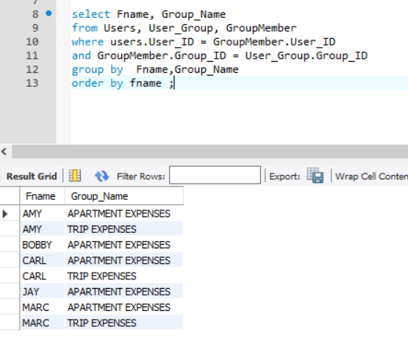

1. Display user name and sum of all non-group expenses for a user.

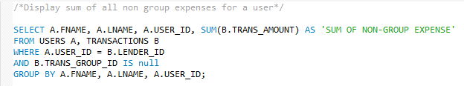

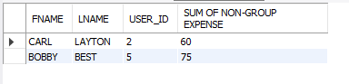

1. Display average, maximum, minimum and total of Debt amount by a user.

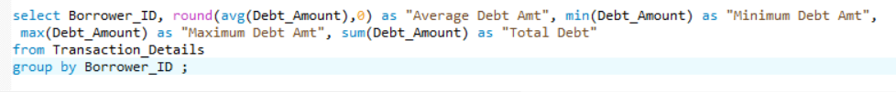

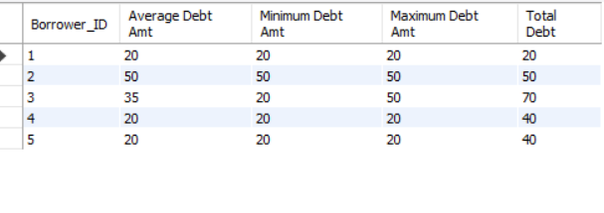

1. Display average, maximum, minimum and total expense by a user



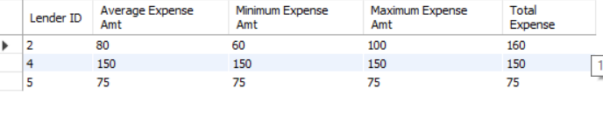

1. Display the no of pending settle up requests for every user.

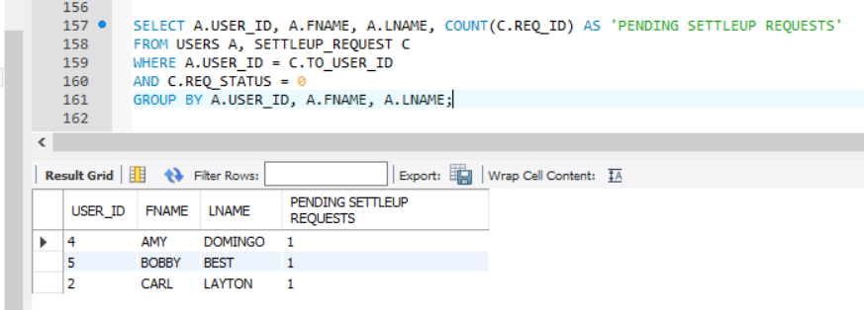

1. Display the amount borrowed by each user which is not repaid or settled.

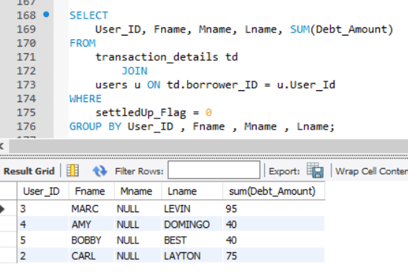

1. Display the list of Transaction ID and Transaction comments that are associated with each Settleup request.

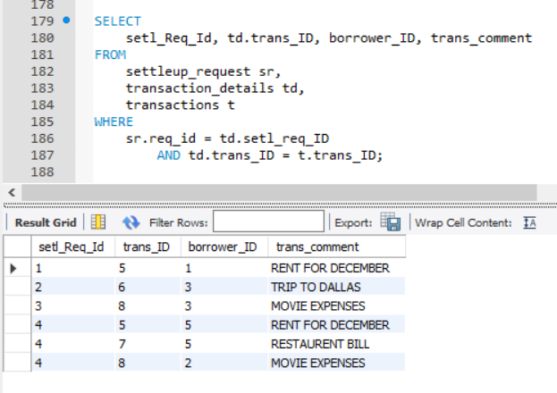

1. Display the list of pending settleup requests in each user queue from all users.

